[Opening Slide]

Good evening, everyone! I’m Ge Haizhou a Ph.D. from TBSI Class 23, majoring in Data science and information technology.

Today, I will introduce reinforcement learning—a field that's transforming the way machines **learn and make decisions**. Imagine a computer that not only processes information but also learns from its experiences, just like humans do.

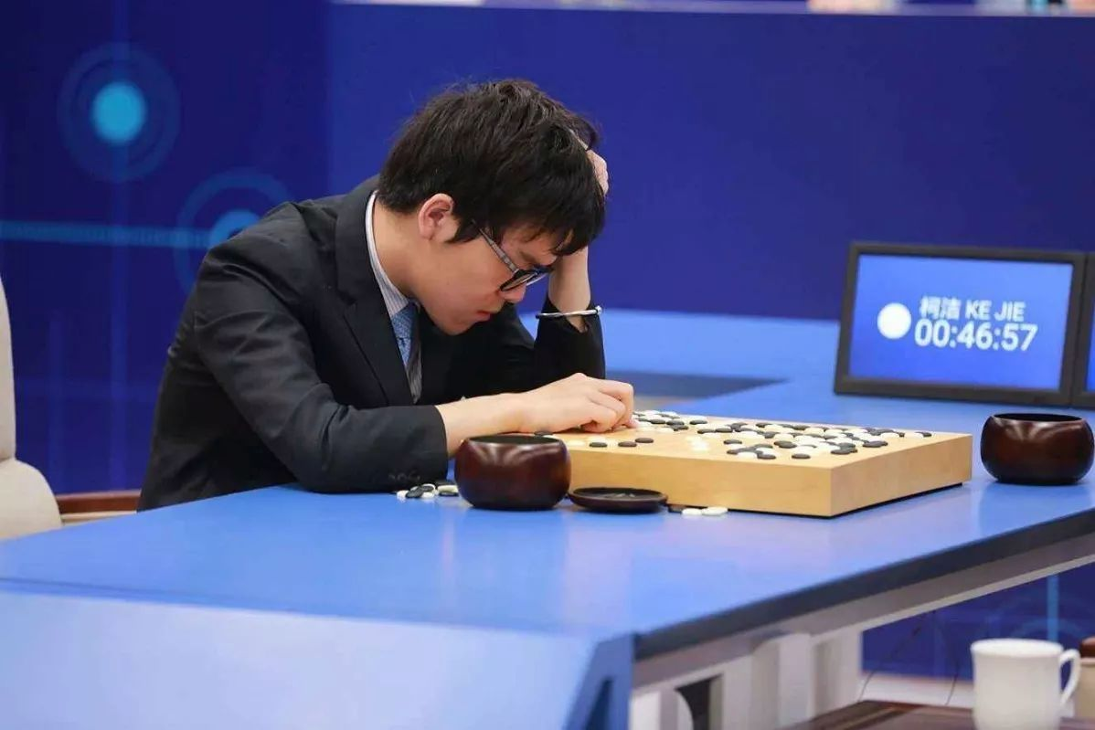

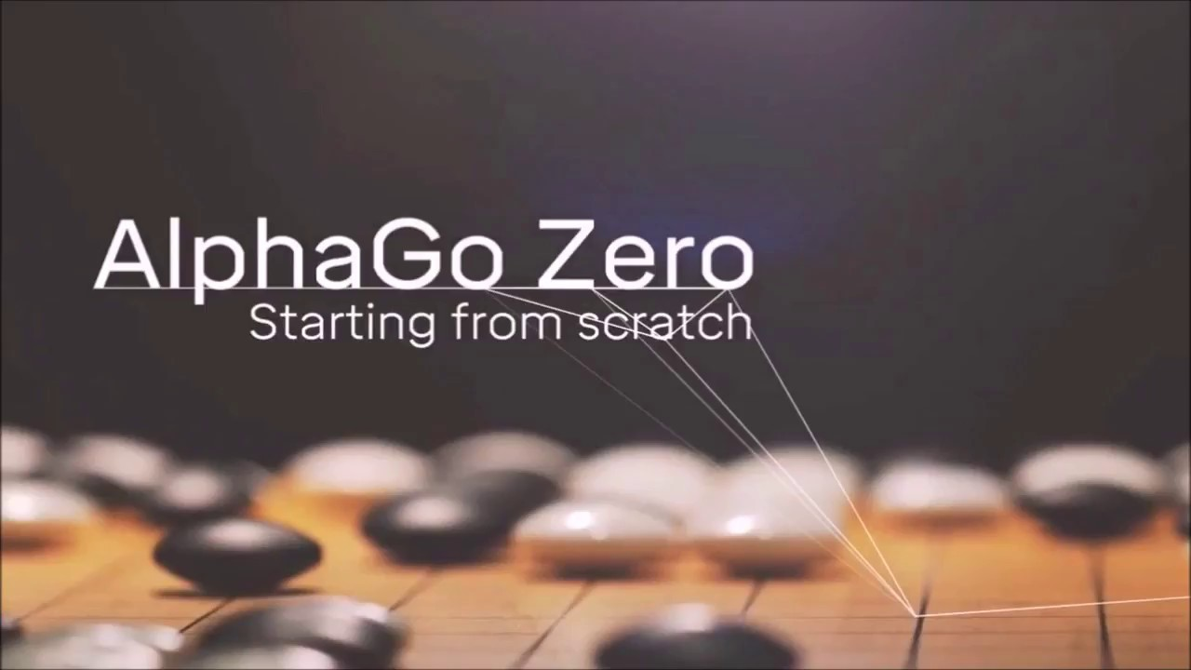

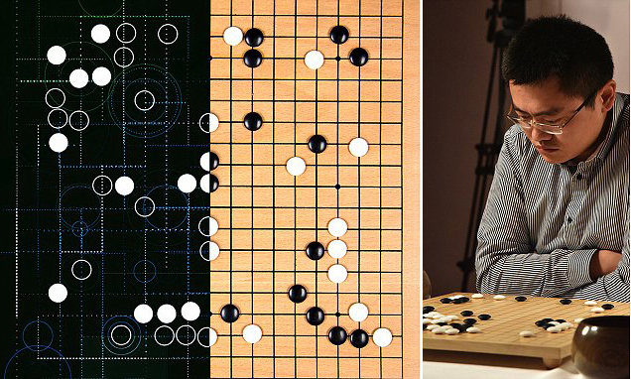

[Slide 1: What is Reinforcement Learning?]

So, what exactly is reinforcement learning? In simple terms, it's a type of machine learning where an **agent** learns to make decisions by interacting with an environment. Think of it as teaching a computer to play a game or control a robot by **trial and error**.

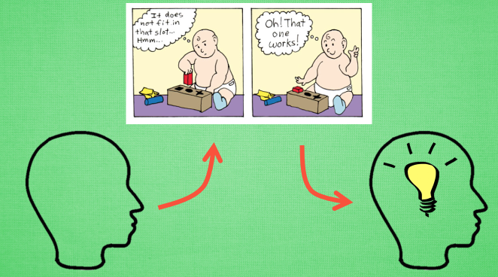

[Slide 2: Learning by Example]

Now, let's break it down further. Imagine teaching a dog a new trick. When it performs the trick correctly, you give it a treat. If it makes a mistake, you might **withhold the treat**. Reinforcement learning works in a similar way. **The computer, or the "agent,"** takes actions in an environment, and based on the outcomes, it learns what actions lead to rewards and which ones result in penalties.

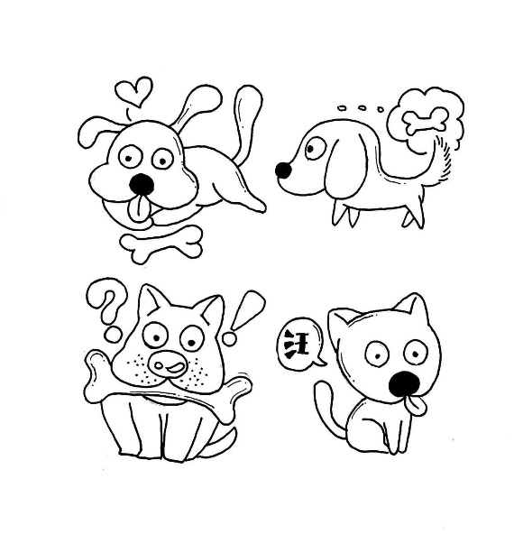 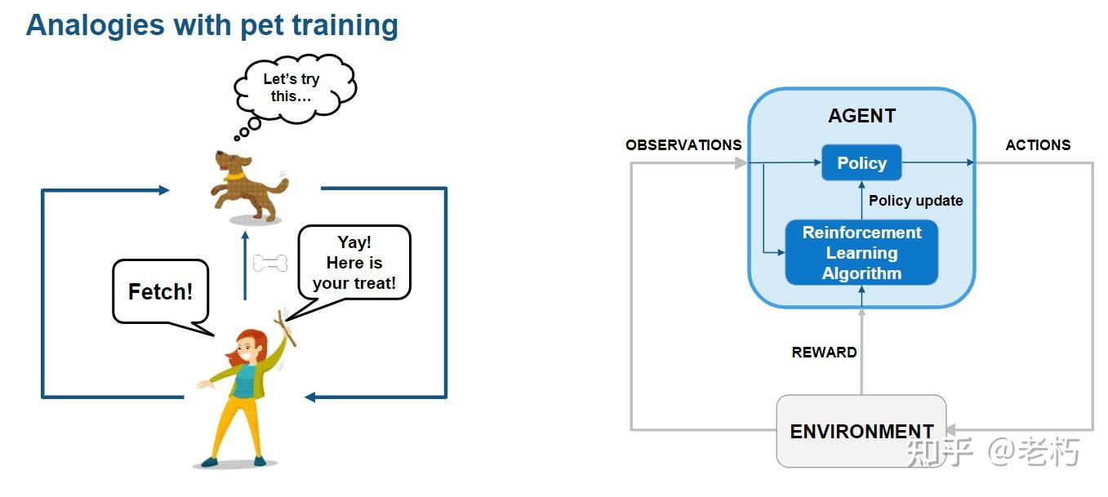

[Closing Slide]

In conclusion, reinforcement learning is a powerful approach that enables machines to learn and adapt in a dynamic world. The journey **of machines becoming smarter** is unfolding **right before** our eyes, thanks to the exciting frontier of reinforcement learning. Thank you!

